Muddy — Hackathon Documentation
Oct 29, 2026 · Mario Espinoza-Gutierrez

Muddy is a one-tap, anonymous "I'm lost" button for live lectures. It shows the instructor, slide by slide, where the class gets confused, and gives students a list of slides to review afterward. Built for the IU Indianapolis Education Hackathon, October 2026, by Mario Espinoza-Gutierrez.

The problem
In a large lecture, instructors usually find out students were lost when the exam grades come back. By then the class has moved on two or three topics, and the gap has grown.
The feedback that would help arrives too late because confused students rarely speak up during class, especially in a bigger lecture’s. They don't want to look slow in front of a hundred classmates. They often can't put the question into words yet. And by the time they could, the lecture has moved to the next slide. The students who most need help are the least likely to ask for it.
Instructors aren't short on tools, but the existing ones don't fit this moment. Polling apps like Slido and Poll Everywhere only collect feedback when the instructor stops to ask a question, so confusion between questions goes unseen. Office hours and end-of-class surveys come after the fact and depend on students remembering what lost them. Teachers have long used the "muddiest point" technique, asking students at the end of class to write down the most confusing part, precisely because this gap is real. But a paper slip at the end of the hour can't tell you which slide caused the trouble, or help while you're still teaching.

How Muddy solves it
Muddy turns the muddiest point into a live signal. Students say "I'm lost" the moment it happens, with one tap and no name attached, and every tap is tied to the slide on screen.
For students. They scan a QR code on the projector or type a 4-letter room code. There's no account and no app to install. Their phone shows the current slide and one large button. Tapping it marks them as lost for 60 seconds, with a countdown; tapping "Got it now" clears it. Because it's anonymous and silent, saying "I'm lost" costs nothing, which is the whole point.
For instructors. While presenting, a small gauge shows what share of the class is lost right now. When it crosses a level the instructor picks before class (25%, 35% or 50%), a quiet alert appears: "38% lost on slide 12," with a button to jump back to that slide. The instructor can re-explain while it still matters, instead of finding out on the exam.
After class. The instructor gets a report: which slide lost the most students, a timeline of the whole lecture in 30-second blocks, and every slide ranked by how many students got lost. It opens with one clear takeaway, such as "Most of the room got lost on slide 12," so the next lecture can start there. Students get their own end screen listing the three slides most of the class struggled with, which turns the same data into a study guide.
What makes it different. Muddy is continuous and started by the student, not a poll the instructor has to run. Each tap fades after a minute, so the number always means "lost right now," not a total that only grows. And because confusion is recorded per slide, it stays useful long after class ends. Research on slide-linked confusion feedback for recorded lectures found it helps both students and teachers; Muddy brings that idea into the live classroom.

Impact and what's next
Muddy is built for the large courses / classes where students most often fall behind unnoticed: a single lecture hall can hold more students than an instructor could ever check in with one by one. It needs no setup from the university, no student accounts and no paid services, so any instructor can try it in their next lecture with a PDF of their slides.
After the hackathon, the next steps are instructor sign-in so sessions and reports follow you across devices, trends across a whole semester of lectures (which topics confuse every cohort), anonymous questions attached to a tap, and Canvas integration.

Technical details
Muddy is a React + TypeScript web app hosted on Vercel, with Supabase providing the database, live updates, anonymous sign-in and slide storage. It uses no AI models and runs entirely on free tiers.
Part | Technology | What it does
Frontend | React, TypeScript, Vite, Sass | Instructor and student screens, one codebase
Database | Supabase Postgres | Sessions and timestamped events
Live updates | Supabase Realtime | New taps to the instructor; slide and status changes to phones
Identity | Supabase Anonymous Auth | A random ID per phone, no names or emails
Slides | pdf.js, Supabase Storage | PDF upload, rendered sharply in the browser
How data flows. Each phone sends three kinds of events, each tagged with the current slide: a heartbeat every 30 seconds, "lost," and "got it." Realtime pushes each new event to the instructor's screen as it's saved, and pushes slide and status changes back to every phone. The session's status (lobby, live, ended) decides which screen each device shows, so a refresh lands back in the right place.
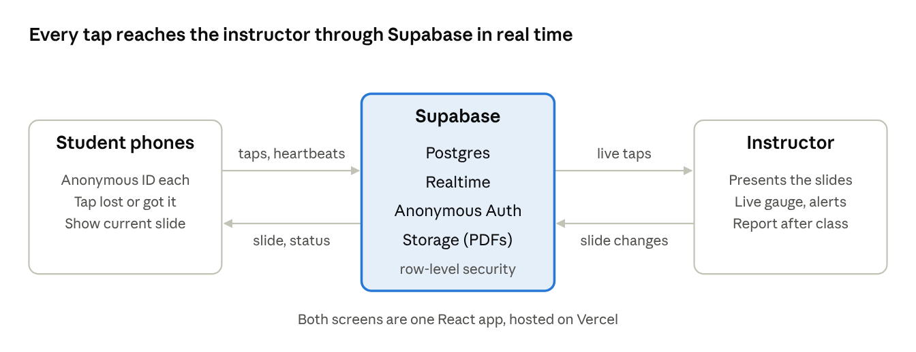
Muddy architecture · phones, Supabase, instructor
The confusion number. Each phone counts once, however often it taps:
\text{lost now} = \frac{\text{phones whose latest "lost" tap is under 60 s old and not cleared}}{\text{phones seen in the last 2 minutes}}
The report replays this same function at the end of every 30-second block of the lecture, loading the session's events in pages of 1,000 rows so long lectures aren't cut off.
Security and privacy. Row-level security rules mean a phone can only add events under its own anonymous ID, and only while the session is open. Only the browser that started a session can change its slides or status, upload slides, or open its report.
Testing. Unit checks cover the confusion math, including repeat taps, expired taps and "got it." A simulator script signs in 20 anonymous students that send real events and get lost on chosen hard slides, and a database seed function generates a realistic 52-minute lecture for the report.

Extra details: Figma design
The brand and every screen were designed in Figma before they were built, in a light UI that uses one palette across the instructor and student views.
Brand and logo. Four logo directions were explored on one palette: charcoal #262626, sage #ACBFA4, pale green #E2E8CE, tangerine #FF7F11 and red #FF1B1C. The concepts are Drop & Ripple (a tap is a drop hitting the puddle, with the red center where confusion is strongest), Rising m (two arches heating from tangerine to red, the same heat scale used in the app), Muddy Bubble (a dripping speech bubble that stays readable at favicon size) and Puddle (a soft serif wordmark that nods to the muddiest-point technique).
Type and components. Headings use Bricolage Grotesque and interface text uses IBM Plex Sans. A small shared component set (buttons in three states) keeps both views consistent.
Instructor screens. Setup (course, lecture title, slide PDF and the 25%, 35% or 50% alert level), Lobby for the projector (4-letter room code, QR code and a live join count), Presenting with the "Lost now" gauge, Presenting with the pulse and "38% lost on slide 12" alert, and the Report with its "Start here next time" takeaway and lecture timeline.
Student screens. Join (enter the room code, no name asked), Welcome (how it works in three lines), Room with the current slide and the "I'm lost" button, Room after a tap with the countdown until it clears, and Session ended listing the three muddiest slides to review.
Figma files: Logo and brand · Screen UI

